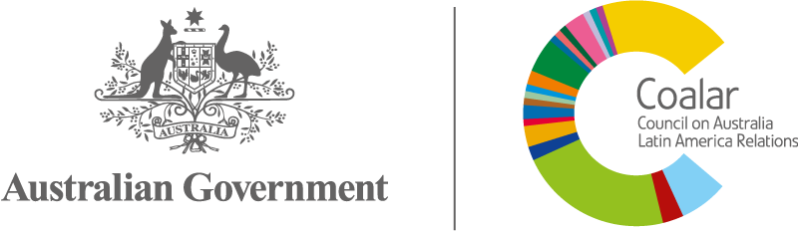 | Council on Australia Latin America Relations  Business Plan 2021-2022

FOCUS THEME - SUSTAINABILITY
COALAR has identified a strategic opportunity to advance its objectives through a sustainability focus in its Business Plan.

Australia and Latin America share common challenges in realising environmental, economic and social sustainability. After many decades of building business, cultural and personal relationships between Australia and Latin America across a diverse range of important issues, the sectors of resources, energy and agriculture continue to form the bedrock of the Australia - Latin America relationship. Markets in these sectors are in an exciting growth phase, underpinned by a sustainability focus. At an expected Compound Annual Growth Rate (CAGR) of 27.1% the green technology and sustainability market alone is expected to grow from USD 8.7 billion in 2019 to USD 28.9 billion by 2024.

Managing population growth alongside increasing environmental awareness and the growing demand for products that are less harmful for the environment, are major factors driving global growth in green technology and sustainability markets. These areas of focus provide opportunities for further commercial engagement, mutual learning, community and institutional linkages between Australia and Latin America.

The global scale and import of sustainability challenges makes attracting meaningful partnerships, projects, and processes, as well as passionate individuals to drive change and transformation, a priority. Activities that create linkages between poverty reduction, natural resource management and development, and local and global environmental challenges, are required to manage shared global environmental risks and build economic, social and environmental resilience.

Guidance from the Board
COALAR’s 2021-2022 Business Plan priority is sustainability.
Sustainability is a complex concept. Put simply, it is development that meets the need of the present, without compromising the ability of future generations to meet their own needs. COALAR’s sustainability focus will seek to encourage Latin America – Australia connections that create, implement and communicate innovative and diverse approaches to sustainability challenges, such as environment, natural resources and energy management, smart cities and the circular economy. COALAR will value innovation and diversity in approaches to sustainability challenges.
The Business Plan will be implemented by directing funding to activities that align to the following themes and strategies:
- Sustainability across COALAR’s priority areas of business, education, tourism and cultural promotion.
- Developing relationships with relevant stakeholders in Australia and Latin America to identify strategic collaboration and engagement opportunities.
- Promoting and supporting economic diplomacy projects and activities that facilitate and grow new business opportunities.
- Promoting and supporting projects that involve sharing and transfer of expertise from which institutions or individuals in both countries would benefit and in ways that would directly advance COALAR’s objectives.
- Developing relationships between stakeholders in Australia and Latin America using digital networking that enables collaboration and virtual engagement opportunities.
- Using activities, programs, awards and networks to promote Australia and Latin America as dynamic and diverse societies.
- Encouraging innovative approaches to strengthen business, education and community links, such as technology and new capabilities.
- Increasing COALAR’s online and social media presence to support connections between Australia and Latin America.
COALAR will provide guidance to ensure all grant activities, including one-off and ad-hoc grants, are aligned with its 2021-2022 priorities. The COALAR open grant round for 2021-2022 will invite applications aligned to the focus theme and strategies.
Measuring success
Successful implementation of the Business Plan will specifically address the theme and strategies to:
- create new business and education-related relationships or opportunities;
- have community benefit;
- achieve geographic spread;
- support diversity; and
- deliver long-term impact.

For example: ‘Our Common Future’, Sustainable Development Goals, Sustainability in business, Social sustainability

