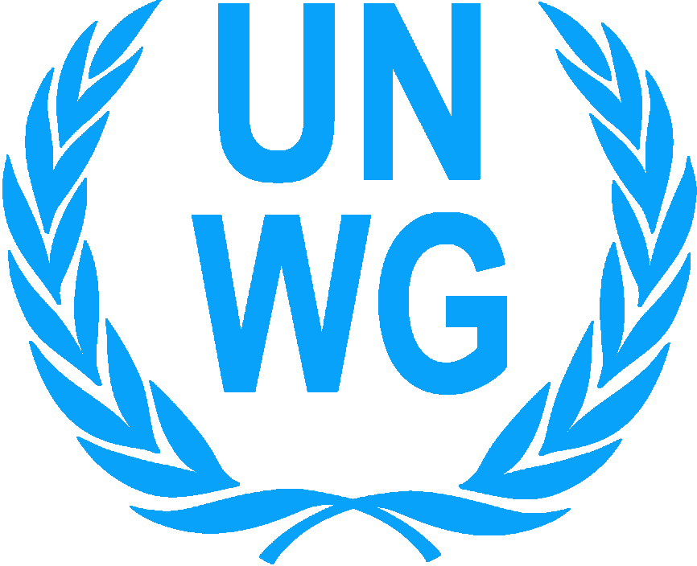 | THE UNITED NATIONS WOMEN’S GUILD OF VIENNA  Vienna International Center, Room F1036, P.O. Box 400, A-1400 Vienna, Austria  Tel.: (+43 1) 2600-24276, 26026-4284, E-mail: unwgcharityvienna@gmail.com,  Homepage: http://unwg.unvienna.org

UNWG APPLICATION FORM FOR CHARITY DONATIONS 2019
PLEASE READ CAREFULLY BEFORE COMPLETING THE APPLICATION
The Application is open between 15 September and 15 December 2018

1. UNWG CRITERIA:
- The project must focus on children in need (not older than age 18 years or 21 if disabled) or on mother/child programs that affect the well-being of the children.
- The project must be for all children / children and mothers without discrimination of gender, race, ethnic origin or religion.
- Projects must be sustainable and have continuation plans.
- The project must address basic needs in health, education, water and shelter, focusing on long term assistance (e.g. Clean water supply, sanitation facilities, school construction or repair, classroom furniture, educational or vocational materials/equipment, medical equipment, special needs support).
- The maximum amount of a grant will be €10,000 or equivalent of this amount.
- Incomplete applications, and those not falling within the UNWG criteria, will not be considered.
- Projects may be funded for maximum of three years within a 10 year period.
- If you have received funds before and have failed to submit a final report, then your application will not be considered for funding.

2. UNWG DOES NOT FUND:
- Administrative costs (rents, salaries of any kind, office supplies, telephone costs, travel expenses)
- School fees, school uniforms or writing materials
- Promotional materials, awareness training or sensitization programmes
- Micro-credit programme or purchase of animals for income generation
- Revenue generating schemes (e.g.: purchase of computer/reprographic equipment for a Cybercafé; building construction or purchase of equipment to be utilized/rented out for commercial purposes/ income generating activities)
- Food and emergency aid i.e. natural disaster, conflict areas etc.
- UNWG does not provide retroactive funding, i.e. project activities must be undertaken after receipt of funds.

3. COMPLETION INSTRUCTIONS
- UNWG prefers applications in the English language, NGO’s may submit in Arabic, Chinese, French, German, Russian or Spanish. However please be aware that we do not have official translators.
- Please type or print clearly throughout the application.
- You may add lines or space to more fully describe an item.
- Letters of support from local government entities are encouraged.
- You must provide your organization’s registration certificate as a non-profit organization with the original application form and contact information for the registration authority. If you are a governmental education or health facility, please provide documentation as to your credentials.
- All amounts must be specified in Euro or US Dollars and so indicated on the application.

- The original application form must be emailed to:
unwgcharityvienna@gmail.com (no later than 15 December 2018, midnight Central European Time)
Or sent by post to:
Second Vice President, UNWG
Vienna International Center, Room F 1036
P.O. Box 400, A-1400 Vienna, Austria (postmarked before 15 December 2018)
- For email applications, the signed last page must be scanned and submitted. For postal mail applications, please submit the original signatures.
- Organizations receiving a grant must submit a detailed project completion report including payment invoices before 30 June 2020.

4. APPLICATIONS PROCESS
The UNWG reserves the right to contact organizations to confirm information found in this application. ALL correspondence will be sent to the name and e-mail address that appears on this page. All applications become the property of the UNWG and will be treated in a confidential manner. We reserve the right to ask for information from other organizations that have a part in the project. The United Nations Women’s Guild may use any information, slides, or photographs pertaining to the project for purposes of exhibits, promotions, publications, or any other activity as may be deemed necessary. The list of approved projects will be placed on the UNWG website by 31 July 2019.

Please note following the review process, NGO’s will only be contacted if their application is under consideration.

ORGANIZATIONAL INFORMATION
- PROJECT TITLE:

1a. PROJECT AMOUNT REQUESTED FROM UNWG:
- PROJECT LOCATION, including the country, city, town, village and street address or geographic coordinates of project site:

- LEGAL NAME of applying organization:

4. POSTAL ADDRESS of your organization:

4a. Web site URL:

4b. Email Address:

5. HEAD of the organization, email and contact address:
Note: This is the same person who authorizes this application.

Email Address:

6. REFERENCE – If you have a person at Vienna International Center or in Vienna who can speak about the project, then please provide their name, address and email. This is not a requirement therefore this will not affect your project evaluation process.

A. ABOUT THE ORGANIZATION
1a. Has your organization received funding from the United Nations Women’s Guild Vienna before? |  |  | □ YES □ NO
1b. If yes, when? What was the purpose of the funding?

Please note if you have received funds before and have failed to submit a final report including evidence of paid bills, then your application will not be considered for funding.
1c. Have you applied for UNWG funding before, please list in which years and the purpose.
1d. How did you find out about the UNWG Charity Programme?:
2. What are the goals and objectives of your organization? (Attach brochures and list web site info)

3. When was your organization founded?

4. Is your organization registered as a Non-profit or charitable organization with your government? A current NGO certificate must be submitted with your application. |  |  | □ YES □ NO
5. Is your organization a government organization? |  |  | □ YES □ NO
6. Please list the projects/activities of your organization during the last 2 years, starting with the latest that you implemented. For each funding source, please include name of contact person, email, and telephone number. Please add additional lines as needed.
Project purpose/activities | Amount | Name of the funding agency |  | Year completed

7. Please provide the following personnel and financial information of your organization in 2017:
7a. Number of paid staff working in the organization:
7b. Number of volunteers in the organization:
For each of the following, please indicate Euro (€) or US Dollars:
7c. What is the yearly budget of your organization in 2017?
7d. Amount spent on salaries in 2017:
7e. Amount spent on administration in 2017:
7f. Amount spent on projects/activities in 2017:
8. What is/are your organization’s regular source(s) of funding? We reserve the right to ask for account details when the project is shortlisted. Please indicate Euro (€) or US Dollars
SOURCE |  | AMOUNT | PERCENTAGE
Membership fees |  |  | %
Self-generated (donations/fund-raising) income |  |  | %
Government |  |  | 100%
International organizations |  |  | %
Others (please specify) |  |  | %
TOTAL |  |  | 100%

B. PROPOSED PROJECT FOR UNWG FUNDING:
(Please attach relevant brochures, documents and 4 photographs)

1. Please describe briefly the project you are applying for UNWG funding.
2. What will be the impact of this project in your community? State the problem this project will address and explain how this will be sustained and/or continued in the future. Use attachment if necessary.
3. Number of children the project will support: Boys: Girls:
In case of mother-child project, please specify the number of:
Boys: Girls: Women:

4. Ages of children:
5. Please give details of disability and/or special needs among children that this project will serve:

6. When do you expect the project to start?

7. How long will it take to complete the project?

8. In chronological order, describe the steps of the plan and implementation dates of each step (note the funds will not be transferred before June).
PLAN STEP |  |  |  |  | EXPECTED DATE
9. What is the estimated TOTAL cost of this project?
10. Amount requested from UNWG
11. Are other organizations/donors contributing to costs? |  |  | □ YES □ NO
11a. Funding detail when other donors are supporting the project:
Source and Contact Information | Amount in € or US$ | Which part of the Project is to be supported?
12. Are you also applying to other organizations/donors for this project? □ YES □ NO
12a. Please provide more information on your application to other donors:
Source and Contact Information | Amount in € or US$ | Which part of the Project is to be supported?
13. ITEMS to be funded by UNWG:
Please list items to be funded using the UNWG funds and the approximate cost of each item.
Where possible, please enclose documents supporting the costs and/or cost estimates from suppliers.
ITEM |  |  |  | COST (in Euro or US dollars)
Example: 3 children’s single beds with wood frames @ €50.00 each |  |  |  | €150.00
Total Cost of Items
Total cost to be paid for by UNWG
C. BANKING INFORMATION

1. Please specify HOW you would prefer payment, if your project is approved for funding:
□ US $ □ €

2. Please complete the following information on the bank where the funds will be deposited:

Name on account
Account number
Bank name
Bank address
IBAN (International Banking Number)
SWIFT Code
Authorization Code to receive foreign funds (where appropriate)
The Name on the Bank account should be the name of the organization applying for funds.
D. Submission

This application has been authorized and submitted by:

Name of the official: (same as on page 3 item 5 of this application)
Title of the same official in the Organization:
Signature of the same official:
Date:
Stamp/Seal of the Organization:

Please sign and submit this page with the application.
A scanned copy is acceptable for electronic submission.

