Towards safeguarding the Ecuador banana industry against Fusarium Wilt TR4 (COALAR 2019-20156)
Sector: Economic Diplomacy, Trade
Country location: Ecuador
Grantee: Queensland University of Technology

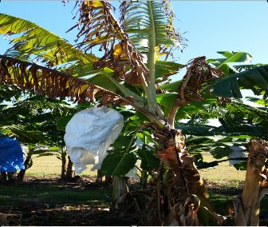
Symptoms of Fusarium wilt TR4 on a Cavendish banana plant growing in the Northern Territory, July 2019 (Credit: James Dale)

Project Description
Fusarium wilt TR4 is a lethal disease which affects more than 50% of the banana crop worldwide. The disease is caused by a soil-borne fungus which spreads through soil, water and infected plant material. There is no effective chemical control for TR4 and there are no commercially acceptable resistant cultivars available to replace vulnerable varieties, which includes Cavendish.

In 2019, TR4 was identified for the first time in Latin America (Colombia). This incursion poses a serious threat to the major banana exporting industries based in Latin America. Ecuador is the largest global banana exporter. To respond quickly and effectively in the event of a TR4 incursion, rapid and accurate detection of the disease is critical.

Scientists from Queensland University of Technology with expertise in TR4 detection techniques will conduct a workshop in Ecuador to provide hands-on training to local scientists on TR4 detection. This will strengthen the Ecuadorian technical capacity in laboratory diagnosis of TR4 and better equip the country to face the threat of the introduction of TR4.
Key Dates
01 September 2019 to 30 November 2019: Preparation for Workshop, Australia
02-06 December 2019: Diagnostics Workshop, Ecuador
15-31 January 2020: Post workshop report, Australia-Ecuador

Social media: https://www.qut.edu.au/institute-for-future-environments/research/research-centres-and-programs/centre-for-tropical-crops-and-biocommodities

Council on Australia Latin America Relations grant offer: $40,000 (exc.GST)
Total project value: $87,875

Contact Person: Prof James Dale (email: j.dale@qut.edu.au : +61 410520269)

Developing Australia’s edible insect industry: better environmental, health and cultural outcomes (COALAR 2019-20159)
Sector: Science, Technology and Innovation
Country location: Australia
Grantee: CSIRO

Edible Insects Grilo Spread_crickets and_ mealworms (Credit: Dr Bryan Lessard)

Project Description
Mexico and Australia share some contemporary environmental and social problems, including clearing land for agriculture and grazing. Both countries also have high rates of obesity and diabetes. Developing the Mexican and Australian edible insect industries not only helps address the above challenges; but also promotes Indigenous traditions, and creates innovative business opportunities.

In August 2019, CRISO organised a three-day international symposium on edible insects in Brisbane, Australia. The symposium brought together leading Mexican and Australian scientists, members of the local Indigenous community and representatives of the Australian edible insects industry. Across the three days, CSIRO identified the benefits, challenges, and opportunities of including native Australian insects in our diet. CSIRO looked to establish future research collaborations in the areas of culture, environment & biosecurity, health & diet, and commercialisation.

Building from the symposium, CSIRO will produce a bilingual industry roadmap to identify the strategic priorities and knowledge required to grow an Australian insect industry. The roadmap will outline the potential environmental benefits and health implications of including insects in our diet. It will also include assessment of the edible insect industry’s potential to empower Indigenous communities. Through a collaboration with world edible insect expert, Dr Rene Cerritos (UNAM-Mexico). This Australia-based project will draw lessons from the Mexican experience.
Key Dates
28-30 August 2019: Developing Australia’s edible insect research and industry to improve environmental, health and cultural outcomes, Brisbane
15 April 2019 to 15 September 2019: Roadmap report, Brisbane & Canberra
20 August 2019 to 15 September 2019: Scientific paper

Social media: #EatBugsAU, @ro_ponce_r, @BrytheFlyGuy, @CSIRO

Council on Australia Latin America Relations grant offer: $21,114 (exc. GST)
Total project value: $65,551

Contact Person: Helen Beringen (email: helen.beringen@csiro.au : +61 738335945)

Empowering women in tourism through entrepreneurial digital competencies (COALAR 2019-20166)
Sector: Technology and Innovation
Country location: Ecuador, Mexico
Grantee: Griffith Institute for Tourism

Women and technology training (Credit: Free image from Pixabay)

Project Description
Women entrepreneurs in Latin America’s tourism sector create employment opportunities in their communities. These entrepreneurs need assistance to grow their businesses. This project will help them to deepen their knowledge of international tourism markets and increase their digital entrepreneurial competency.

This project will deliver digital competency training for women entrepreneurs in the tourism industry in Ecuador and Mexico. It will focus on imparting practical knowledge, including setting up, promoting and managing a business on sharing economy and social media platforms. It aims to deliver training to six cohorts of 20 women.
Key Dates
15 August 2019 to 30 September 2019: Participant interviews to identify training needs, Ecuador and Mexico
15-30 October 2019: Designing of training programme, Brisbane
15 February 2020 to 15 March 2020: Training workshops, Ecuador and Mexico

Social media: https://www.facebook.com/GriffithInstituteTourism/

Council on Australia Latin America Relations grant offer: $36,100 (exc. GST)
Total project value: $59,700

Contact Person: Dr Catheryn Khoo-Lattimore (email: c.khoo-lattimore@griffith.edu.au : +61 468938072)

Enhancing trainer professional skills in an applied learning/research context
(COALAR 2019-20170)
Sector: Education
Country location: Brazil, Chile, Peru
Grantee: TAFE Directors Australia

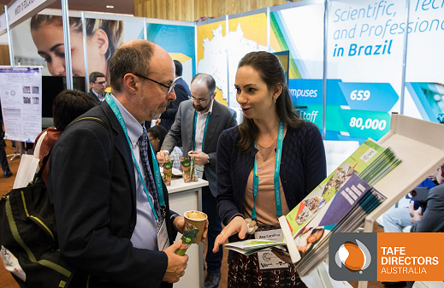
2018 World Congress, Melbourne, Brazilian TVET Providers talking to Australian delegates (Credit: RMIT Student Photography)

Project Description
Australia's vocational education and training (VET) system has a unique approach to the development of trainers in vocational training institutes. This system is widely known across the globe, including amongst partners in Latin America. This project will provide opportunity for partners in Latin America to have a better understanding of the Australian VET system.

In this project, TAFE Directors Australia will draw its expertise from Australian TAFEs to conduct workshop sessions. The workshops will outline the approach of developing a VET workshop based on close industry linkages and a practical approach to skills development. The sessions will focus on increasing the eﬀectiveness of training arrangements and trainers, especially within key priority industry areas such as agriculture and resources.
Key Dates
17-26 February 2020: VET Workforce Workshops, Lima, Chile and São Paolo

Social media: http://www.tda.edu.au

Council on Australia Latin America Relations grant offer: $45,000 (exc. GST)
Total project value: $58,500

Contact Person: Jen Bahen (email: jbahen@tda.edu.au : +61 499174410)

Australia-Brazil Smart City Research and Practice Forum
(COALAR 2019-20181)
Sector: Technology and Innovation
Country location: Brazil
Grantee: Queensland University of Technology

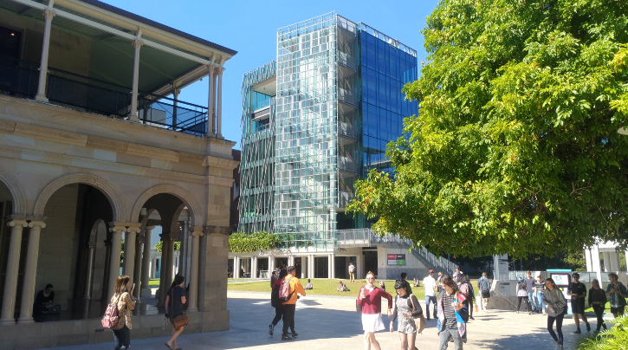
A Snapshot from the Smart Precinct of Queensland University of Technology (Credit: Tan Yigitcanlar)

Project Description
In order to tackle the limiting sustainable urban development issue and to secure a sustainable future, both Australia and Brazil have embraced the concept of ‘smart cities’ that offer a combination of solutions through various technology-driven innovations applied to different urban environments.
This project will establish an ongoing exchange of smart cities research and practice between Australia and Brazil. The exchange will be launched at a forum in Florianopolis with an aim of setting up a formal network to bring both countries closer.
The forum will take place in November 2019 and run in conjunction with the ‘12th Knowledge Cities World Summit (KCWS-2019)’. The target audience (around 200 people) of the forum will be key scholars, policymakers, urban administrators, practitioners, and entrepreneurs from Brazil. Early career academics and research students (around 100 people) will attend as observers. Some of the forum sessions will be open to the KCWS-2019 delegates— about 300 delegates from Brazil and around the world are anticipated to attend. This will increase the direct reach of the forum activities to approximately 600 people.
Key Dates
01 November 2019: Forum Website Launch, Brisbane, Australia
04 November 2019: Site Visit & Networking Reception, Florianopolis, Brazil
05 November 2019: Opening Ceremony & Master Classes, Florianopolis, Brazil
06 November 2019: Master Classes, Florianopolis, Brazil
07 November 2019: Round Table Discussion & Networking Dinner, Florianopolis, Brazil
08 November 2019: Strategy Workshop & Closing Ceremony, Florianopolis, Brazil
01 December 2019: Network Website Launch, Brisbane, Australia

Social media: https://www.linkedin.com/groups/8562103/ https://twitter.com/UrbanStudiesLa1 https://twitter.com/QUT https://www.linkedin.com/school/queensland-university-of-technology/

Council on Australia Latin America Relations grant offer: $44,900 (exc. GST)
Total project value: $105,726

Contact Person: Associate Professor Tan Yigitcanlar (email: tan.yigitcanlar@qut.edu.au : +61 731382418)

Saltwater Academy - Bull Riding School
(COALAR 2019-20236)
Sector: Sport
Country location: Australia
Grantee: Saltwater Country Inc

Saltwater Academy - Adriano Moraes Bull Riding Clinics September 2019 Broome Western Australia (Credit: Sublime Graphic Design)

Project Description
Saltwater Country’s Rodeo clinics provide an engaging experience for young Indigenous Australians that can lead to lifelong positive change and build enduring relationships between individuals and communities in Australia and internationally. This project will build on Australia and Brazil’s shared history of outback ranching and rodeo to provide a unique sporting and mentorship opportunity.
Adriano Moraes is Brazil’s three-time world Professional Bull Riding Champion and a legend of the sport. We will bring Adriano to Broome, Western Australia, to guide and support the next generation of Australian Indigenous bull riders through intensive training clinics. Participants will engage and learn new skills and celebrate the culture and shared history of rodeo from Latin America. The exchange will have something for everyone, including rodeo and campdraft, cultural experiences, country music, and Bull Riding Clinics for all ages. The project will start an interchange between Australia and Latin America cowhands to create a mutual cultural understanding and generate professional opportunities in rodeo competitions.
Saltwater Country is a grassroots Indigenous organisation built on the symbolic power of the cowhand in remote Australia. We create opportunities for community involvement and development to deliver long-lasting self-determined positive change. The team has a track record and conscious business model ensuring Aboriginal engagement, procurement, training and employment.
Key Dates
13 September 2019: Community Meet & Greet, Nyamba Buru Yawuru
14 September 2019: Under 14 Bull Riding Clinic, Broome Rodeo Ground
15 September 2019: Under 18 Bull Riding Clinic, Broome Rodeo Ground
20 September 2019: Rhythm & Ride Campdraft & Kids Git Up Day, Broome
21 September 2019: Rhythm & Ride Rodeo, Broome

Social media: Facebook - @SWCBroomeWA, @RhythmandRideBroomeWA Instagram - rhythm_and_ride,
www.saltwatercountry.com.au, www.rhythmandride.com.au

Council on Australia Latin America Relations grant offer: $50,000 (exc. GST)
Total project value: $115,000

Contact Person Cara Peek, Chairperson (email: marketing@saltwatercountry.com.au : +61 417205729)

Circolombia Australian Tour
(COALAR 2019-2040)
Sector: Arts and Culture
Country location: Australia
Grantee: Arts Projects Australia Events Pty Ltd

Cast photo - Circolombia's "Acelere" (Credit: Roberto Ricciuti 2017)

Project Description
Circolombia is a live entertainment production company based in both London and Bogota to promote and provide the world’s stage with the dramatic difference of Colombian performers. Circolombia was founded in 2006 to provide professional opportunities for graduates of Colombia’s national circus school, Circo Para Todos (the world’s first professional circus school for disadvantaged youth).

Circolombia prides itself on uniting and celebrating youth through its productions, as well as helping young people start their journey of self-development and discovery.

Circolombia’s upcoming show “Acelere” will showcase 13 performers in order to celebrate Colombia’s diversity, through risky performances from aerialists, acrobats and contortionists with dance and live music.

It will be a world-class performance you will never forget.
Key Dates
1-11 October 2019: 2020 Fringe Program Announcement, Online, Print, Media,
14 February 2020: Season preview/opening, Venue, Adelaide

Social media: https://www.artsprojects.com.au/, https://adelaidefringe.com.au/, https://www.facebook.com/ADLfringe, https://www.facebook.com/ArtsProjectsAustralia/, #ADLfringe

Council on Australia Latin America Relations grant offer: $30,000 (exc. GST)
Total project value: $579,019

Contact Person: Ian Scobie (email: iscobie@artsprojects.com.au : +61 882711488)

Crop-livestock adaptation to climate change based on modelling and remote-sensing (COALAR 2019-2049)
Sector: Science, Technology and Innovation
Country location: Australia, Argentina, Uruguay
Grantee: University of Tasmania

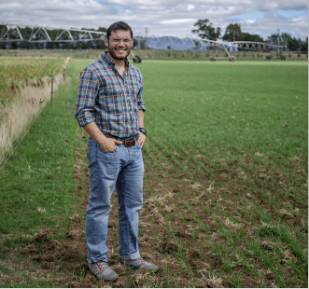
Dr Jonathan Ojeda (Tasmanian Institute of Agriculture) is working with USQ, UBA-UNER Argentina and INIA Uruguay to assess how crop-livestock practices impact farm performance under different climate change scenarios (Credit: Mees Arkesteijn)

Project Description
Good livestock management and policies are crucial to maintaining economic stability, while addressing the challenges of climate change. Yet the policies and practices guiding the industry vary by region and nation.

This project will hold three workshops. The workshops aim to assess how crop-livestock management practices impact regional farming performance under different climate change scenarios. Technologies, which will be used to assess the yield variability for diverse forage cropping systems, include existing model-scaling and remote-sensing techniques developed in Argentina (the most advanced biophysical models in the world). These assessments will take place in Argentina, Uruguay, and Australia. The workshops will also strengthen crop-livestock management skills for the three countries in different areas: systems modelling (Australia), remote-sensing system (Argentina), and livestock systems analysis (Uruguay).

The project will be conducted collaboratively with livestock industry decision makers who will perform foresighting exercises to explore alternative futures. This will facilitate the development of forage crop regional management and preparation for environmental impacts.
Key Dates
15-21 April 2020: Workshop led by Dr Ojeda and Ara, Ciudad de Buenos Aires, Argentina,
06-10 July 2020: Workshop led by Dr Irisarri and Mr. Della Nave, Hobart and Toowoomba, Australia,
14-18 September 2020: Workshop led by Dr Pembleton and Ojeda, Buenos Aires (Argentina) and INIA La Estanzuela (Uruguay)

Council on Australia Latin America Relations grant offer: $49,956 (exc. GST)
Total project value: $154,428

Contact Person: James Fagg (email: james.fagg@utas.edu.au : +61 3 6226 1809)

Brazil-Australia partnership on preventing domestic and gender-based violence (COALAR 2019-2050)
Sector: Public Policy
Country location: Australia
Grantee: Monash University

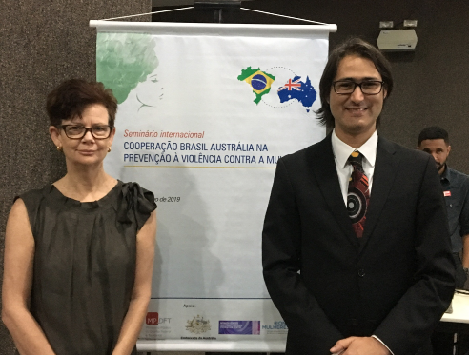
Jude McCulloch, Professor of Criminology, Director of the Monash Gender and Family Violence Prevention Centre and Thiago Pierobom de Ávila, Associate Professor UniCEUB and Senior Prosecutor at the Office of the Attorney General, Brasilia, Brazil (Credit: Photo taken by Monash Gender and Family Violence Prevention Centre)

Project Description
Brazil is recognised as a leader in family violence prevention, particularly policies and laws addressing femicide (the gendered killing of women, most commonly intimate partner homicide). Family violence is receiving unprecedented funding and policy attention in Australia. Victoria’s Royal Commission into Family Violence led to a program of transformative change designed to end gendered and family violence.

This project will bring Brazilian government, non-government, academic and justice-sector professionals to Australia to establish a research network focused on public policy innovation to prevent family and gender-based violence in Brazil and Australia. Subsequently, the research network will promote deeper understandings of domestic violence research, policy and practice in both countries.
Key Dates
09-13 December 2019: workshops, seminars, site visits, Melbourne

Social media: https://arts.monash.edu/gender-and-family-violence @monashGFV

Council on Australia Latin America Relations grant offer: $27,231 (exc. GST)
Total project value: $35,312

Contact Person: Dr Naomi Pfitzner (email: naomi.pfitzner@monash.edu : +61 399058048)

Building local capacity for aquatic wildlife’s sustainable management: Patagonia, Argentina (COALAR 2019-2080)
Sector: Science, Technology and Innovation
Country location: Argentina
Grantee: Centro Nacional Patagonico (CENPAT) – Consejo Nacional de Investigaciones Cientificas y Técnicas (CONICET)

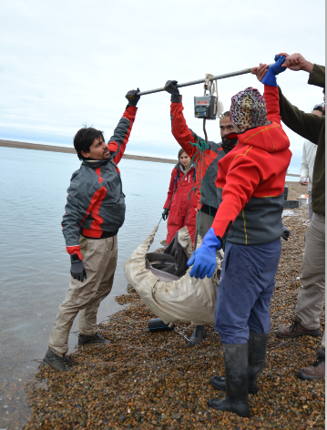
Weighing aquatic wildlife in Patagonia (Credit: Photographer Noela Sanchez)

Project Description
Patagonia’s waterways possess significant levels of biodiversity. The region is facing environmental challenges, such as overfishing, mining and marine pollution, that threaten its aquatic wildlife.

Through a series of community talks and workshops, this project will teach local communities about Patagonian aquatic wildlife on how these animals interact with their environment and how communities can manage aquatic resources more sustainably. This project will also produce a short film on management of Patagonian aquatic animals for educational purposes.
The project is led by world expert on aquatic animal habitat utilisation, Dr Adam Barnett from James Cook University.
Key Dates
24 October 2019 to 07 November 2019: Film production, Puerto Madryn
24-25 October 2019: Meeting key donors, Buenos Aires
29 October 2019 to 01 November 2019: Scientists fieldwork workshop, Puerto Piramides
01 November 2019: Community talk, Puerto Madryn
04-06 November 2019: Scientists workshop, CENPAT Puerto Madryn

Social media: https://www.facebook.com/pg/ProyectoArrecife-236632783083170/photos/?ref=page_internal; https://www.gea-cenpat.com/, https://www.facebook.com/cenpat.conicet, @cenpat.conicet

Council on Australia Latin America Relations grant offer: $11,210 (no GST)
Total project value: $82,796.15

Contact Person: Dr Cynthia Awruch (email: awcynthia@cenpat-conicet.gob.ar : +54 92804007651)

